T

TIBCO BusinessEvents: Views

Product Suite | TIBCO BusinessEvents
Product | Views
Product Version | 5.1
Initial Author | Anand Patil

Copyright Notice
COPYRIGHT© 2011 TIBCO Software Inc. This document is unpublished and the foregoing notice is affixed to protect TIBCO Software Inc. in the event of inadvertent publication. All rights reserved. No part of this document may be reproduced in any form, including photocopying or transmission electronically to any computer, without prior written consent of TIBCO Software Inc. The information contained in this document is confidential and proprietary to TIBCO Software Inc. and may not be used or disclosed except as expressly authorized in writing by TIBCO Software Inc. Copyright protection includes material generated from our software programs displayed on the screen, such as icons, screen displays, and the like.
Trademarks
Technologies described herein are either covered by existing patents or patent applications are in progress. All brand and product names are trademarks or registered trademarks of their respective holders and are hereby acknowledged.
Confidentiality
The information in this document is subject to change without notice. This document contains information that is confidential and proprietary to TIBCO Software Inc. and may not be copied, published, or disclosed to others, or used for any purposes other than review, without written authorization of an officer of TIBCO Software Inc. Submission of this document does not represent a commitment to implement any portion of this specification in the products of the submitters.
Content Warranty
The information in this document is subject to change without notice. THIS DOCUMENT IS PROVIDED "AS IS" AND TIBCO MAKES NO WARRANTY, EXPRESS, IMPLIED, OR STATUTORY, INCLUDING BUT NOT LIMITED TO ALL WARRANTIES OF MERCHANTABILITY OR FITNESS FOR A PARTICULAR PURPOSE. TIBCO Software Inc. shall not be liable for errors contained herein or for incidental or consequential damages in connection with the furnishing, performance or use of this material.
For more information, please contact:
TIBCO Software Inc.
3303 Hillview Avenue
Palo Alto, CA 94304
USA
Table of Contents
TIBCO BusinessEvents: Views 1
1 Change Log 4
1.1 Related Documents 4
2 Introduction 5
2.1 Main Objective 5
2.2 Intended Usage 5
2.3 Scope 5
2.4 Audience 5
3 Acronyms and Vocabulary 5
4 General Requirements 5
4.1 Packaging 5
5 Non-Functional Requirements 5
6 Functional Requirements 5
6.1 Resource Creation Toolbar 5
6.1.1 User Interface 5
6.1.2 User Interactions 6
6.2 Resource Creation Wizards 7
6.2.1 Metric 7
6.2.2 Data Source 10
6.2.3 View 12
6.2.4 Role Preference 14
7 High Level Design 15
7.1 Resource Creation Toolbar 15
7.2 Resource Creation Wizards 15
8 Technology Overview 15

Change Log
.
Date | Version | Name | Description
10/18/2011 | 1.0 | Anand Patil | Initial doc

Related Documents
Document Title | Revision Number | Author

Introduction

Main Objective

The document explains the enhancements to be made to the Business Events Views Studio Plug-ins.

Intended Usage

The document is intended to be used by developers.

Scope

Audience

The document is intended for User Interaction Designers, Developers, Architects, QA and Managers.

Acronyms and Vocabulary

General Requirements

Packaging
The packaging will be within the current BE Views add-on

Non-Functional Requirements

Functional Requirements

Resource Creation Toolbar

User Interface

The creation toolbar should be created as follows

- A button to create metric
- A button to create data source
- A drop-down button to create skin elements
  - Series Color [default]
  - Chart Component Color Set
  - Text Component Color Set
  - Skin
  - System Elements
- A drop-down button to create components
  - Chart [default]
  - State Machine Component
  - Page Set Selector Component
- A button to create dashboard page
- A button to create View
- A button to create Role Preference

User Interactions

  - All the toolbar actions must be enabled if selected resource is in a studio project or is a studio project
  - The tool bar action should launch the appropriate wizard

Resource Creation Wizards

Metric

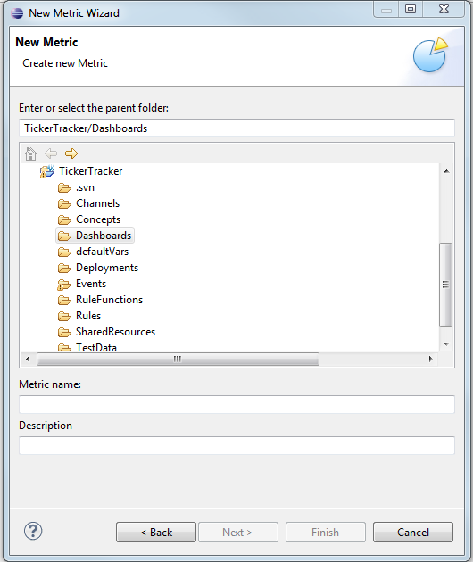
Figure 1 Metric Wizard Creation Page

User Interactions
- The next & finish button should be enabled when user types a valid metric name
- When the user initiates a next or finish, we should create a valid metric with a single group by and a single aggregate field

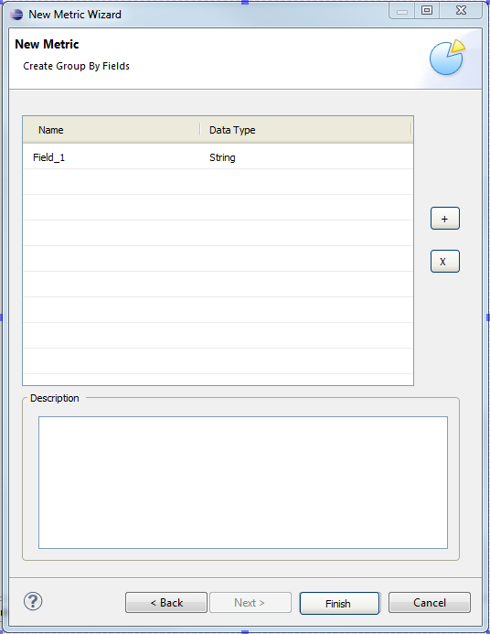
Figure 2 Metric Group By Fields Page

User Interactions
- The next & finish button should be disabled if user removes all group by fields
- The remove (x) button is enabled when user selects one or more fields in the table
- Enable the description text box when the user selects only one field in the table. Update the description text box with the description of the selected field. Allow description to be modified via the text box.
- Add button (+) adds a new group by field with an auto-generated name and data type as string
- Remove button (x) removes the selected field

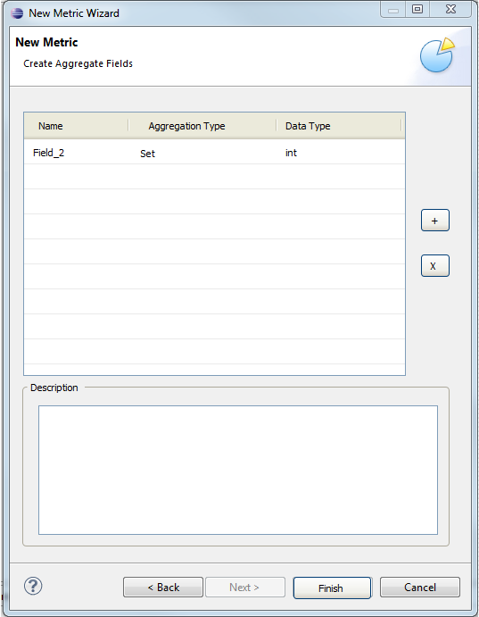
Figure 3 Metric Aggregate Fields Page

User Interactions
- The next & finish button should be disabled if user removes all aggregate fields
- The remove (x) button is enabled when user selects one or more fields in the table
- Enable the description text box when the user selects only one field in the table. Update the description text box with the description of the selected field. Allow description to be modified via the text box.
- Add button (+) adds a new aggregate field with an auto-generated name and data type as int and aggregate type as set
- Remove button (x) removes the selected field

Data Source

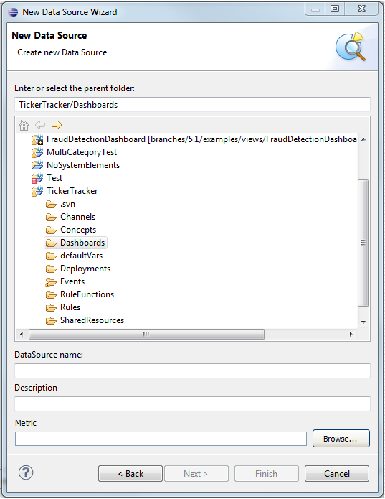
Figure 4 Data Source Creation Page

User Interactions
- If the user launched the wizard whilst selecting a single metric, then metric text field should be populated with the selected metric else it should be populated with the first metric in the project
- The next & finish button should be enabled when user types a valid metric name
- The user can change the metric selection via the ‘Browse…’ button
- When the user initiates a next or finish, we should create a valid data source with the selected metric as the source element and the query as “select * from <full path of selected metric>;”

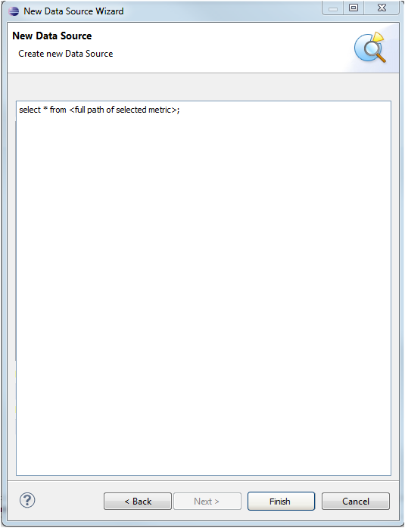
Figure 5 Data Source Query Page

User Interactions
- The finish button should be disabled if user clears the query text area
- Validate the query text as the user types and disable the finish button if validation fails. The validation messages should be shown in the title area of the page (the white area)

View

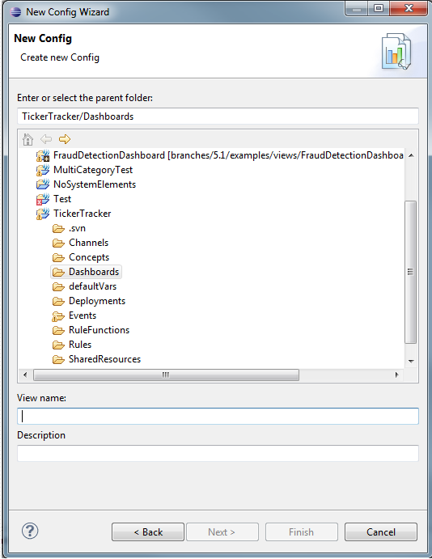
Figure 6 View Config Creation Page

User Interactions
- The next & finish button should be enabled when user types a valid config name
- When the user initiates a next or finish, we should create a valid config. If the user launched the wizard whilst selecting one or more dashboard pages, then we should add the selected dashboard pages to the config else we should add the first dashboard page in the project

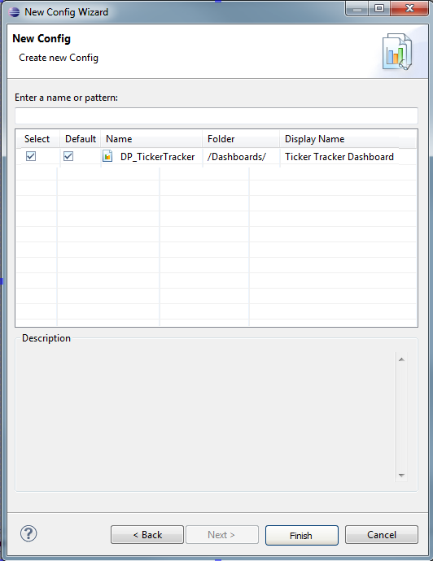
Figure 7 View Dashboard Page Page

User Interactions
- The next & finish button should be disabled if user unselects all dashboard pages
- Entering text in the search prompt should filter the list of dashboard pages visible (see chart selector dialog for feature behavior)
- The description text box should show the selected page description if the user selects one page only (again see the chart selector dialog for feature behavior)

Role Preference

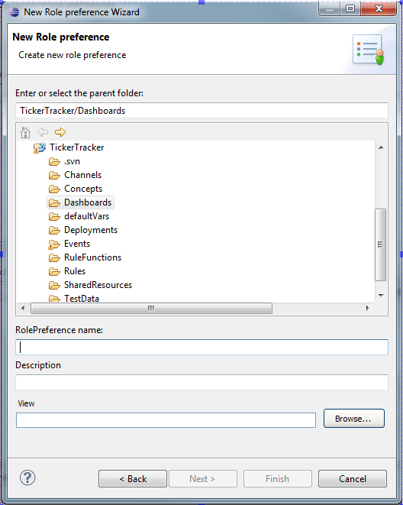
Figure 8 Role Preference Creation Page

User Interactions
- If the user launched the wizard whilst selecting a single view, then view text field should be populated with the selected view else it should be populated with the first view in the project
- The next & finish button should be enabled when user types a valid role preference name
- The user can change the metric selection via the ‘Browse…’ button
- When the user initiates a next or finish, we should create a valid role preference with the selected view as the ‘view’.

High Level Design

Resource Creation Toolbar

We should leverage the eclipse plug-in extension mechanism. The ‘com.tibco.cep.studio.dashboard.ui’ plug-in should be the one which contributes the tool bar. The ‘com.tibco.cep.studio.dashboard.ui’ should also define a component creation extension point. The component creation extension point manifests as the item in the drop down for component button. The extension point should provide name, image, default, command handler and any other relevant properties. The first default implementation is default. The ‘com.tibco.cep.studio.dashboard.ui.chartcomponent’ should implement the component creation extension point for chart creation and define itself as the default. The ‘com.tibco.cep.studio.dashboard.ui.statemachinecomponent’ should implement the component creation extension point for state machine component

Resource Creation Wizards

The wizard now needs to be aware of the selection of resources.

- Resource Creation : Refer to the dashboard page wizard to understand how to create a fully valid resource
- Page Selector : Refer to com.tibco.cep.studio.dashboard.ui.widgets.MemberComponentsEditor

Technology Overview

The UI will be developed using JFace

